
AD742A (R100)
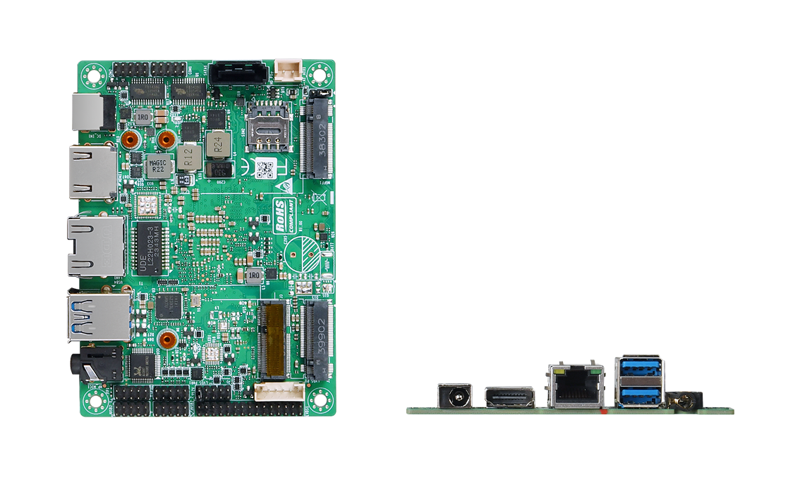

Features：
- Onboard Intel Alder Lake-N series processors;
- Onboard LPDDR5 memory, total maximum 16GB;
- 1 x Intel i226-V network, POE for option;
- 1 x LVDS/EDP, 1 x HDMI, M-Key, E-Key, B-Key;
- 2 x COM, 8_bit GPIO
- DC 12V; Size: 100x72mm

Product Specifications
Processor System | Onboard Intel Alder Lake-N series processor, with or without fan
Processor System | EFI BIOS
Memory | Board-mounted LPDDR5 memory slot, up to 16GB
Storage | M-Key 2242, PCIe4.0 x2 protocol
Storage | 1 x SATA3.0, 2Pin power supply
Display | 1 x HDMI2.0, 4K @60Hz
Display | 1 x LVDS/EDP
Board Edge I/O | DC JACK, HDMI, 2 x USB3.2, 1 x LAN, Audio
Extended interface/function | External TPM2.0 is optional, not available by default
Extended interface/function | 1 x E-Key (PCIe+USB2.0 protocol, WIFI/BT module)
Extended interface/function | 1 x B-Key (USB2.0+ USB 3.0 protocol, 4G/5G module)
Extended interface/function | 2 x COM, RS232 /422/485, pitch 2.0mm, BIOS selection
Extended interface/function | 2 x JUSB2.0 pin header, 2x5Pin, pitch 2.0mm
Extended interface/function | 8_Bit GPIO
Extended interface/function | 1 x 4Pin PWM CPU FAN
Power Supply | DC 12V, 60W
Working Environment | Working temperature: -20℃ ~ +60℃; Working humidity: 5% ~ 90%
Working Environment | Storage temperature: -40℃ ~ +85℃; Storage humidity: 5% ~ 90%
Operating System | Windows10, Windows11, Linux
Size | 100 x 72 mm​
Net Weight | Approximately 100g without radiator, approximately 220g with radiator
AD742A (R100)

Measurement Unit：mm

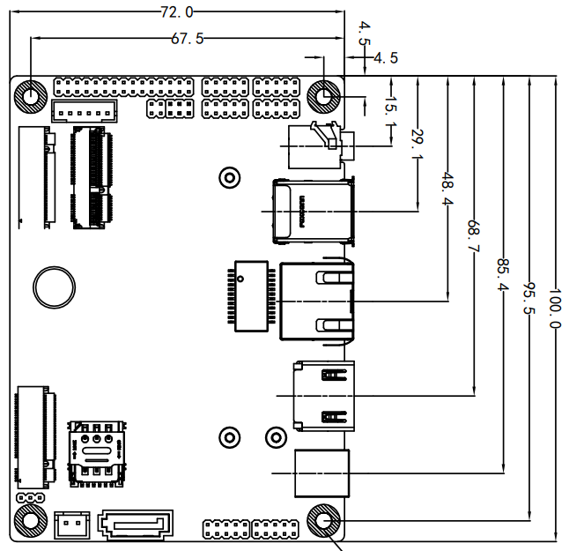

Ordering Information
Model | Options | Descriptions
AD742A | Onboard Intel Alder Lake-N series processor | N100/N305, with or without fan optional
AD742A | TPM2.0 | External TPM2.0 optional
AD742A | LVDS/EDP optional | LVDS/EDP optional
AD742A | POE optional​ | POE optional​

