
PX700CA（R100）

Product Feature:
- Onboard AMD RYZEN 6000/7000 series processors
- 2*DDR5 SO-DIMM, total max 64GB
- 2*RTL8125B network
- TPM2.0, M.2 SSD, M.2 WIFI
- 2*HDMI2.0,2*Type-C (USB3.0+DP)
- DC 12-19V; Size: 100x100mm

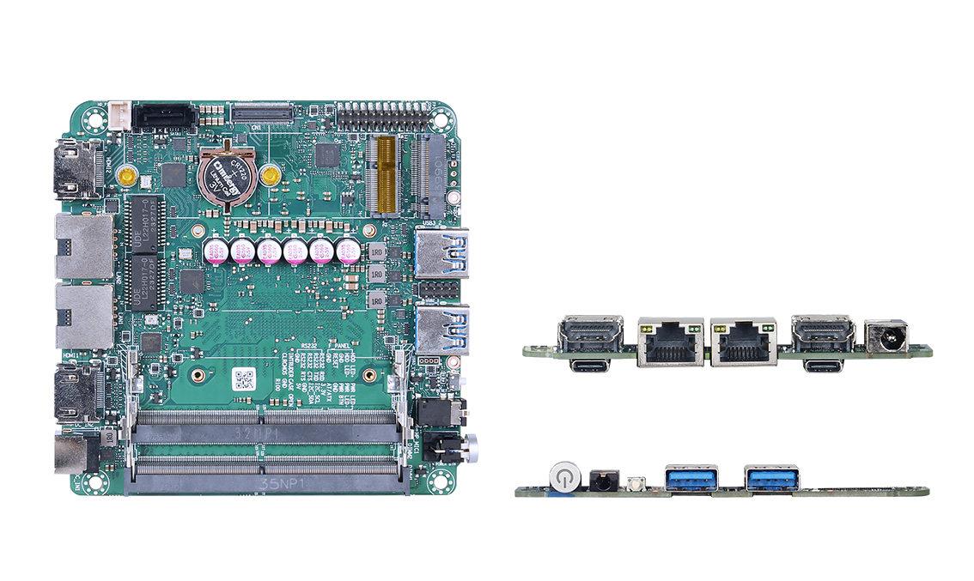

Specification
Processor System | AMD RYZEN 6000/7000 series processor on board, TDP 35W
Processor System | EFI BIOS
Memory | 2*DDR5 SO-DIMM, total max. 64GB
Storage | 1*M.2 M-Key 2280(NVMe PCIe 4.0 x4 protocol)
Storage | 1*SATA3.0 port, 2Pin 5V power supply
Display | 2*HDMI2.0 interface, support 4K@60Hz
Display | 2*Type-C interface, support DP 8K@60Hz和USB3.0
Board Side I/O Interface | Power on button, 2-in-1 audio jack, reset button, 2*USB3.0
Board Side I/O Interface | DC JACK, 2*HDMI, 2*Type-C
Board Side I/O Interface | Dual Network (RTL8125B)
Expansion Interfaces/Features | External TPM2.0 optional, not available by default. Default is CPU built-in TPM2.0
Expansion Interfaces/Features | 1*M.2 E-Key (PCIe+USB2.0 protocol, WIFI/BT module)
Expansion Interfaces/Features | 1*RS232 pin, pitch 2.0mm
Expansion Interfaces/Features | 1*USB2.0 Pin, 2x5Pin, 2.0mm pitch
Expansion Interfaces/Features | 1*4Pin PWM CPU FAN
Expansion Interfaces/Features | 1*FPC (PCIe4.0 4x)
Expansion Interfaces/Features | 1*CIR (not available by default, reserved function, software debugging required)
Power Supply | DC 12-19V, 90W and above
Operating Environment | Operating Temperature: -20℃ ~ +60℃; Operating Humidity: 5% ~ 90
Operating Environment | Storage Temperature: -40°C ~ +85°C; Storage Humidity: 5% ~ 90%
Operating System Support | Windows 10, Windows 11, Linux
Dimension | 100x100 mm
Net Weight | Approx. 120g without heat sink, approx. 220g with heat sink
PX700CA（R100）

Product Size Unit：mm

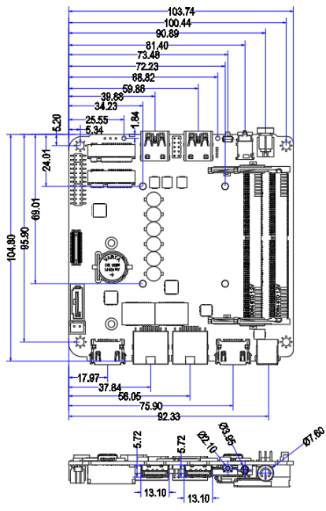

Order Information
Module | Optional items | Description of options
PX700CA | AMD RYZEN 6000/7000 series processor | 6600H/  7735U/7535U/7735HS
PX700CA | TPM2.0 | External TPM2.0 optional

