
AD600NA6L（R100）

Product Feature:
- Onboard Intel 12th/13th-U/-P serial processor
- 2*DDR5 SO-DIMM，max support 64GB
- 6*2.5G lan port（5*Intel i226-V，1*RTL8156B）
- TPM2.0，2*M.2 2280 SSD，M.2 WIFI
- 1*HDMI2.0，1*DP，Type-C（USB3.0+DP）
- DC 12-19V；Size：120x120mm

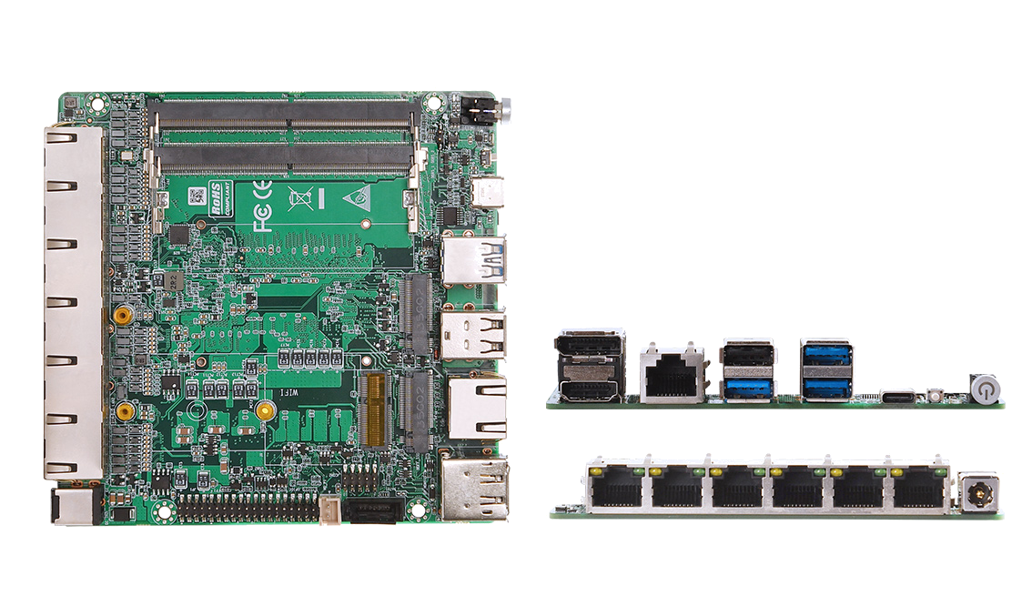

Product Specification
Processor System | Onboard Intel 12th/13th-U/-P series processor, TDP 35W
Processor System | EFI BIOS
Memory | 2*DDR5 SO-DIMM, total max 64GB
Storage | 2*M.2 M-Key 2280(NVMe PCIe 4.0 x4/SATA3.0 protocol), order notes
Storage | 1*SATA3.0, 2Pin 5V power supply
Display | 1*HDMI2.0, support 4096x2160@60Hz
Display | 1*DP, support 7680x4320@60Hz
Display | 1*Type-C port, support DP 7680x4320@60Hz和USB3.2 Gen2
Board Side I/O Interface | Power on button, reset button, 3*USB3.0, 1*USB2.0
Board Side I/O Interface | DC JACK, 1*HDMI, 1*DP, 1*Type-C (USB3.0+DP)
Board Side I/O Interface | 6*LAN, 1*Console (common LAY with RS232/485 pins), TF card
Expansion Interfaces/Features | External TPM2.0 is optional, not available by default. Default is CPU built-in TPM2.0
Expansion Interfaces/Features | 1*M.2 E-Key (PCIe+USB2.0 protocol, WIFI/BT module)
Expansion Interfaces/Features | 1*RS232/RS485 (hardware loading and BIOS setting switching) row of pins, pitch 2.0mm
Expansion Interfaces/Features | 1*USB2.0 Pin, 2x5Pin, 2.0mm pitch; 8 bit GPIO Pin, 2.0mm pitch
Expansion Interfaces/Features | 1*4Pin PWM CPU FAN
Power Supply | DC 12-19V, 120W or above
Operating Environmen | Operating Temperature: -20℃ ~ +60℃; Operating Humidity: 5% ~ 90
Operating Environmen | Storage Temperature: -40℃ ~ +85℃; Storage Humidity: 5% ~ 90%
Operating System Support | Windows 10, Windows 11, Linux
Dimension | 120x120 mm
Net Weight | Approx. 130g without heat sink, 250g with heat sink
AD600NA6L（R100）

Product Size Unit：mm

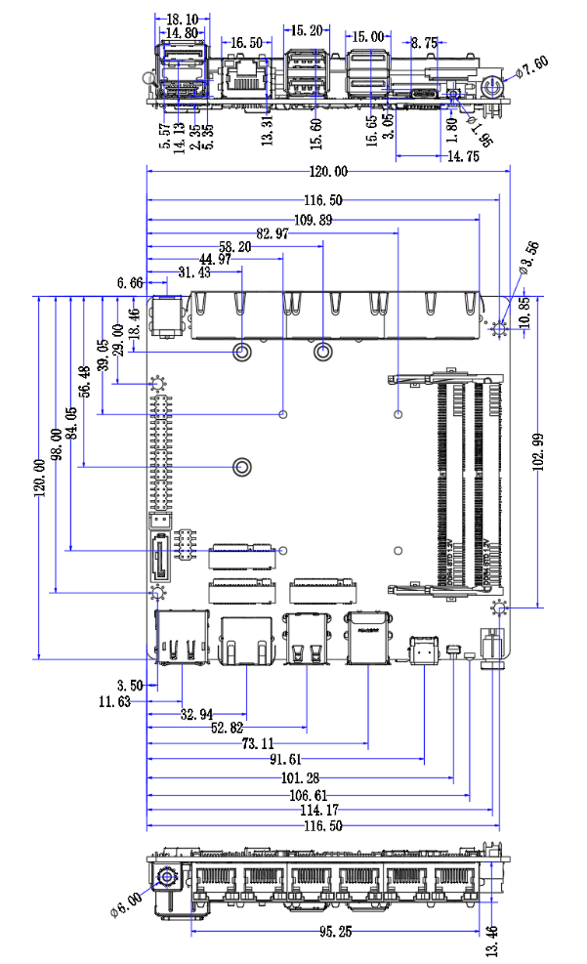

Order Information
Module | Optional items | Description of options
AD600NA6L | Onboard Intel 12th/13th Generation -U/-P Series Processors | 12th Generation -U/-P Series Processors  13th Generation-U/-P Series Processors
AD600NA6L | TPM2.0 | External TPM2.0 optional
AD600NA6L | RS232/485 | Hardware material, BIOS setting switch
AD600NA6L | M.2 2280 SSD protocol away from memory | PCIe4.0 x4 and SATA3.0 protocol optional, jump resistor

